**EXPERIMENT 1**

**Aim:**

Write program in ARM Assembly language for the below Experiments:

1. Load Value to register R0 and copy it in to other general purpose registers using move command.
2. Add two values with
3. Immediate Addressing
4. Direct Addressing
5. Indirect Addressing

**Tool used:** Keil uVision4

**Theory:**

The ARM is a Reduced Instruction Set Computer (RISC) system. In ARM Processor, all instructions are 32 bits long. Most instructions execute in a single cycle. Every instruction can be conditionally executed. LDR instruction is used to Load the value in the register and MOV instruction is used to move the content of one register to another register. Here we have loaded the value of R0 using ‘=’ keyword.

Three types of addressing are:

1. **Immediate Addressing**: It is used to load a constant value into register. Example: MOV R0, #10
2. **Register Direct Addressing**: It is used to move data between two registers. Example: MOV R0, R1
3. **Register Indirect Addressing**: It is used to load data from an address stored in a register. Example: LDR R0, [R1]

**Code:**

1. **Copy content of R0 into R1 to R14**

 AREA PROGRAM, CODE, READONLY

 ENTRY

MAIN

 LDR R0, =0X00000001

 MOV R1, R0

 MOV R2, R0

 MOV R3, R0

 MOV R4, R0

 MOV R5, R0

 MOV R6, R0

 MOV R7, R0

 MOV R8, R0

 MOV R9, R0

 MOV R10, R0

 MOV R11, R0

 MOV R12, R0

 MOV R13, R0

 MOV R14, R0

 END

**Register Output:**

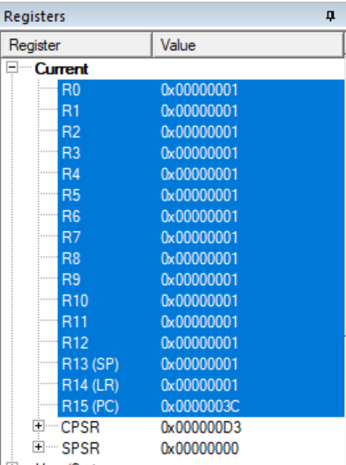

1. **Modes of Addressing:**
2. **Immediate Addressing:**

**Code:**

 AREA PROGRAM, CODE, READONLY

 ENTRY

MAIN

;immediate addressing mode

 LDR R0,=0X00000001

 LDR R1,=0X00000002

 ADD R2,R1,R0

 END

**Register Output:**

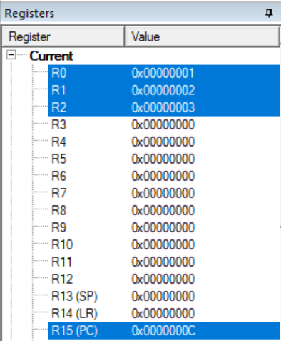

1. **Register Direct Addressing:**

**Code:**

 AREA PROGRAM, CODE, READONLY

 ENTRY

MAIN

;direct addressing mode

 LDR R0,VALUE1

 LDR R1,VALUE2

 ADD R2,R1,R0

 AREA PROGRAM, DATA, READONLY

VALUE1 DCD &00000001

VALUE2 DCD &00000002

 END

**Register Output:**

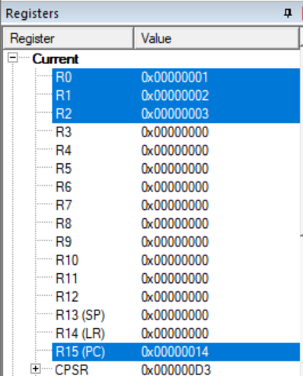

1. **Register Indirect Addressing:**

**Code:**

 AREA PROGRAM, CODE, READONLY

 ENTRY

MAIN

;indirect addressing mode

 LDR R1,VALUE1

 LDR R2,VALUE2

 LDR R3, [R1]

 LDR R4, [R2]

 ADD R5, R3, R4

 AREA PROGRAM, DATA, READONLY

VALUE1 DCD &00000000

VALUE2 DCD &00000004

 END

**Memory Map:**

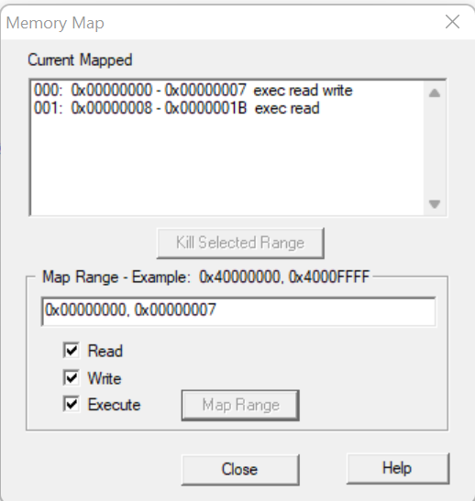

**Value assignment in Memory**

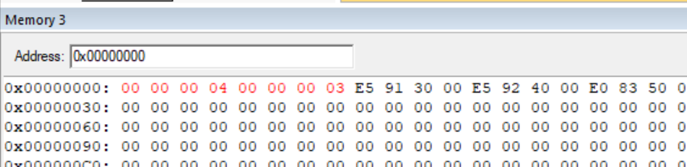

**Register Output:**

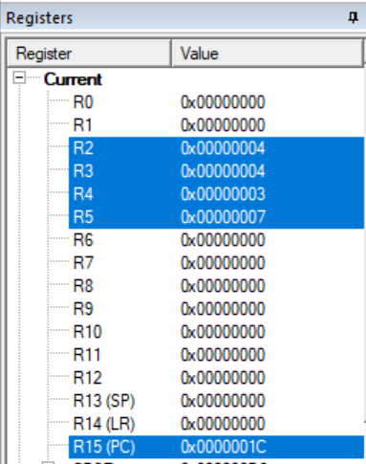

**Result:**

All the parts of the experiments are performed successfully and their results are also verified correctly.